**GLA University, Mathura -2020**

***Mini Project***

***Final Report***

|  |
| --- |
|  |
|  |  |

**TEAM DETAILS**

**Name Git-Hub Usernames**

1. ISHA PARVEEN ishaparveen
2. UTKARSH RATHOR Rathore777
3. JAYESH GUPTA jayeshgupta123789
4. RITIK LAMBA ritiklamba1804
5. KAUSTUBH SISODIA kaustubhsisodia06

***PROJECT NAME: “SMART GESTURE SYSTEM”***

***Supervised By:-Amir Khan***

***CONTENT***

1. INTRODUCTION

1.1 General Introduction to the topic

1.2 Problem Introduction

1.3 Objective

1.4 Motivation

1.5 Proposed Work

2. Software Requirement Analysis

2.1 Methodology

2.2 Hardware Requirements

2.3 Software Requirements

2.4 Installation of Software and Packages

2.5 Design of the Project

3. IMPLEMENTATION DETAILS

3.1 Circuit diagram

4. SOFTWARE DESIGN

4.1 Flow Chart

4.2 Use Case Diagram

4.3 Data Flow Diagram

5. CONCLUSION

6. FUTURE SCOPE

7. APPLICATION

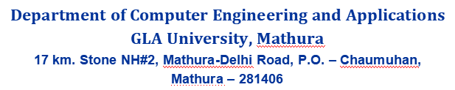

***Declaration***

*We hereby declare that the work which is being presented in the Mini Project “****Hand Gesture System using IOT”,*** *in partial fulfilment of the requirements for Mini-Project LAB, is an authentic record of our own work carried under the supervision of* ***Amir Khan, Technical Trainer, GLA University, Mathura****.*

* ISHA PARVEEN (181500278)
* RITIK LAMBA (181500577)
* JAYESH GUPTA (181500297)
* KAUSTUBH SISODIA (181500318)
* UTKARSH RATHOR (181500771)



***CERTIFICATE***

This is to certify that the project entitled ***“****Smart Gesture System using IOT****”*** carried out is a bonafide work done by *Kaustubh Sisodia (181500318), Ritik Lamba (181500577), Jayesh Gupta (181500297), Utkarsh Rathore (181500771) and Isha Parveen (181500278)* is submitted in partial fulfilment of the requirements for the award of the degree Bachelor of Technology (Computer Science & Engineering).

**Signature of Supervisor:**

**Name of Supervisor: Mr.Amir Khan**

***Project Synopsis***

**Project Information:**

|  |  |
| --- | --- |
| Title Of Project/Training/Task | Smart Gesture System |
| Role & Responsibility | Isha Parveen: Documentation work  Jayesh Gupta: Arduino work  Utkarsh Rathor: Python coding section  Ritik Lamba: Arduino work  Kaustubh Sisodia: Python coding section |
| Technical Details | Hardware Requirements:   * Arduino UNO x 1 * Ultrasonic Sensors x 2 * USB Cable (for Arduino) * Few Connecting Wires * A Laptop with internet connection     Software Requirements:   * Arduino IDE * Python IDLE * PySerial library (We will use to communicate with serial ports). * PyAutogui library (We will use to perform actions). |
| Implementation Detail | Fully Implemented |
| Application Software | Python IDE  Arduino IDE |
|  |  |

**Summary of the Training Work:**

|  |
| --- |
| During the completion of this project , we learnt about the python, usage of Arduino and basic implementation of IoT. Jayesh Gupta is the founder of the project. Ritik lamba has worked on Arduino implementation along with Jayesh. Kaustubh Sisodia has also implemented the python coding section along with Utkarsh Rathor. Isha Parveen has worked on python coding as well as arduino’s implantation along with documentation.  Our mentor **Mr.Amir Khan** guided us and helped us a lot whenever required by us |

**ACKNOWLEDGEMENT**

It gives us a great sense of pleasure to present the report of the B. Tech Mini Project undertaken during B. Tech. Third Year. We have taken efforts in this project. However, it would not have been possible without the kind support and help of teachers. We would like to extend our sincere thanks to them.

We are highly indebted to Mr. Amir Khan for his guidance and constant supervision as well as for providing necessary information regarding the project and also for his support in completing the project.

We would like to express our gratitude towards our parents and members of GLA University for their kind co-operation and encouragement which helps us in completion of this project.

***Abstract***

The report presents the following tasks that is being in continuation during college time at GLA University which are listed below:

1.Understanding of the Problem objective and implication

2.Understanding of the data & building of the model

3.Evaluation of the model

All these tasks have been completed successfully and results were according to expectations. All the tasks were need very systematic approach, starting from the collection of the data to the implementation of the solution and till evaluation of the system. The most challenging task was the domain knowledge, to understand the language. It is one of the major areas and really need very fundamental and conceptual knowledge.

***1.INTRODUCTION***

**1.1 General Introduction:**

In this project, we are going to learn how to build gesture-controlled laptops or computers. It is based on using the combination of Arduino and Python.

Instead of using a keyboard, mouse or joystick, we can use our hand gestures to control certain functions of a computer like to play/pause a video, move left/right in a photo slideshow, Scroll up/down in a web page and many more. This is why I decided to control VLC Media Player as a hand gesture project.

The idea behind the project is quite easy by using two Ultrasonic Sensors (HC-SR04) with Arduino. We will place the two sensors on the top of a laptop screen and calculate the distance between the hand and the sensor. Counting on the information from Arduino that is sent to Python through the serial port, this information will then be read by Python which is running on the computer in order to perform certain actions.

You might have seen Hand Gesture Controlled Robots, where the motion of a robot is controlled by the gestures of the hand. Another interesting project based on a similar principle is an Arduino based Hand Gesture Control of your computer or laptop.

Human Machine Interface or HMI is a system comprising of hardware and software that helps in communication and exchange of information between the user (human operator) and the machine .We normally use LED Indicators, Switches, Touch Screens and LCD Displays as a part of HMI devices. Another way to communicate with machines like Robots or Computers is with the help of Hand Gestures .In this project, we have implemented a simple Arduino based hand gesture control where you can control few functions of your web browser like switching between tabs, scrolling up and down in web pages, shift between tasks (applications), play or pause a video and increase or decrease the volume (in VLC Player) with the help of hand gestures.

**1.2 Problem Introduction:**

We normally use LED Indicators, Switches, Touch Screens and LCD Displays as a part of HMI devices. Another way to communicate with machines like Robots or Computers is with the help of Hand Gestures.

Instead of using a keyboard, mouse or joystick, we can use our hand gestures to control certain functions of a computer like play/pause a video, move left/right in a photo slide show, scroll up/down in a web page and many more.

**1.3. Objective:**

The principle behind the Arduino based Hand Gesture Control of Computer is actually very simple. All you have to do is use two Ultrasonic Sensors with Arduino, place your hand in front of the Ultrasonic Sensor and calculate the distance between the hand and the sensor. Using this information, relevant actions in the computer can be performed.

The position of the Ultrasonic Sensors is very important. Place the two Ultrasonic Sensors on the top of a laptop screen at either end. The distance information from Arduino is collected by a Python Program and a special library called PyAutoGUI will convert the data into keyboard click actions. Our objective is to make this device simple as well as cheap so it can be produced and used for number of purposes. The objective of this project is to build a iot device that can be controlled by gesture wirelessly. In this project user is also able to control motions of the hand by wearing controller glove and performing predefined gestures.

**1.4 Motivation**

The principle behind the Arduino based Hand Gesture Control of Computer is actually very simple. All you have to do is use two Ultrasonic Sensors with Arduino, place your hand in front of the Ultrasonic Sensor and calculate the distance between the hand and the sensor. Using this information, relevant actions in the computer can be performed.

The position of the Ultrasonic Sensors is very important. Place the two Ultrasonic Sensors on the top of a laptop screen at either end. The distance information from Arduino is collected by a Python Program and a special library called PyAutogui will convert the data into keyboard click actions.

**1.5 Proposed Work**

Gesture controlling is based on specifying hand position from the ultrasonic sensor. For processing the raw data, a micro-controller is essential; for that we use Arduino UNO board. Via USB connection the microcontroller transfers the processed and calculated distance value which is provided by the sensor. The data which is send by the sensor is processed in the software in PC where all the calculations are performed and the data is matched with the predefined conditions (gesture resolution). In this model two ultrasonic sensors are used to detect hand position and are connected to the Arduino board. As we know ultrasonic sensor continuously emits sound and it gets reflected back from user’s hand. The distance between the sounds is send and detection of reflect back sound wave is calculated by the micro-controller.

**2. Software Requirement Analysis**

**2.1 Methodology:**

The design of the circuit is very simple, but the setup of the components is very important. The Trigger and Echo Pins of the first Ultrasonic Sensor (that is placed on the left of the screen) are connected to Pins 11 and 10 of the Arduino. For the second Ultrasonic Sensor, the Trigger and Echo Pins are connected to Pins 6 and 5 of the Arduino.

Now, coming to the placement of the Sensors, place both the Ultrasonic Sensors on top of the Laptop screen, one at the left end and the other at right. You can use double sided tape to hold the sensors onto the screen.Coming to Arduino, place it on the back of the laptop screen. Connect the wires from Arduino to Trigger and Echo Pins of the individual sensors. Now, we are ready for programming the Arduino. Once all work is done then we are ready to demonstrate our project of hand gestuire as our objective is to make this device simple as well as cheap so it can be produced and used for number of purposes.

**2.2 Hardware Requirements:**

* Arduino UNO x 1
* Ultrasonic Sensors x 2
* USB Cable (for Arduino)
* Few Connecting Wires
* A Laptop with internet connection

**Arduino**

**Arduino is** an open-source electronics platform based on easy-to-use hardware and software. **Arduino** boards are able to read inputs - light on a sensor, a finger on a button, or a Twitter message - and turn it into an output - activating a motor, turning on an LED, publishing something online also **used for** building electronics projects. It consists of both a physical programmable circuit board and a software, or IDE (Integrated Development Environment) that runs on your computer, where you can write and upload the computer code to the physical board. The **Arduino Programming Language** is basically a framework built on top of C++. You can argue that it's not a real **programming language** in the traditional term, but I think this helps avoiding confusion for beginners. A program written in the **Arduino Programming Language** is called sketch.

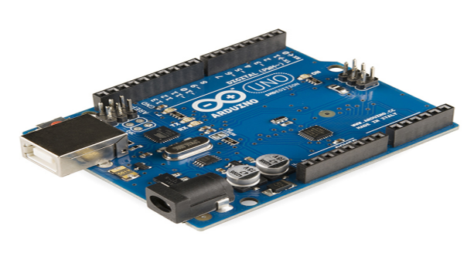

**Ultrasonic sensor**

An **ultrasonic sensor** is an electronic device that measures the distance of a target object by emitting **ultrasonic** sound waves, and converts the reflected sound into an electrical signal. **Ultrasonic** waves travel faster than the speed of audible sound (i.e. the sound that humans can hear).**Human** Presence **Detection** with **Ultrasonic Sensors**. MaxBotix **ultrasonic sensors** solve the common problem of **sensing human** presence. Our **ultrasonic sensors** offer the ability to **detect** people over a wide range of distances with a high read rate and excellent reading to reading stability and **made** with piezoelectric crystals, use high frequency sound waves to resonate a desired frequency and convert electric energy into acoustic energy, and vice versa. **Ultrasonic** sensors work by sending out a sound wave at a frequency above the **range** of human hearing. ... The sensor determines the **distance** to a target by measuring time lapses between the sending and receiving of the **ultrasonic** pulse. The working principle of this module is simple.

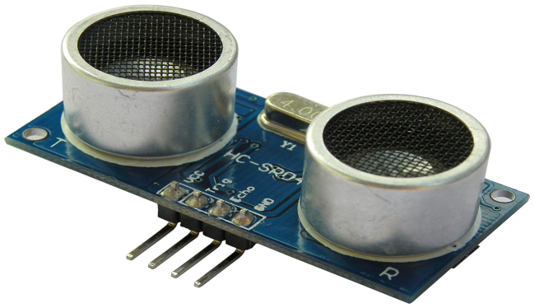

**2.3 Software Requirements:**

* Arduino IDE
* Python IDLE
* PySerial library (We will use to communicate with serial ports).
* PyAutogui library (We will use to perform actions).

**Arduino IDE**

The **Arduino Integrated Development Environment ([IDE](https://en.wikipedia.org/wiki/Integrated_development_environment" \o "Integrated development environment))** is a [cross-platform](https://en.wikipedia.org/wiki/Cross-platform" \o "Cross-platform) application (for [Windows](https://en.wikipedia.org/wiki/Windows" \o "Windows), [macOS](https://en.wikipedia.org/wiki/MacOS" \o "MacOS), [Linux](https://en.wikipedia.org/wiki/Linux" \o "Linux)) that is written in functions from [C](https://en.wikipedia.org/wiki/C_(programming_language)" \o "C (programming language)) and [C++](https://en.wikipedia.org/wiki/C%2B%2B_(programming_language)" \o "C++ (programming language)).It is used to write and upload programs to [Arduino](https://en.wikipedia.org/wiki/Arduino" \o "Arduino) compatible boards, but also, with the help of third-party cores, other vendor development boards. It is the main text editing program used for **Arduino** programming. ... Essentially, the **IDE** translates and compiles your sketches into code that **Arduino** can understand. Once your **Arduino** code is compiled it's then uploaded to the board's memory.

The open-source Arduino Software (IDE) makes it easy to write code and upload it to the board. It runs on **Windows**, **Mac OS X**, and **Linux**. The environment is written in Java and based on Processing and other open-source software. **So** the **Arduino** hardware is easy, the **Arduino** IDE is simple, and the code itself is much easier to comprehend (than trying to program an off-the-shelf microcontroller). ... Another reason **Arduino** is **so popular** is because there are many people using it which means there's a lot of examples out there to work with.

**Python IDE**

**IDLE** (short for **Integrated Development and Learning Environment**) is an [integrated development environment](https://en.wikipedia.org/wiki/Integrated_development_environment" \o "Integrated development environment) for [Python](https://en.wikipedia.org/wiki/Python_(programming_language)" \o "Python (programming language)), which has been bundled with the default implementation of the language since 1.5.2b1.It is packaged as an optional part of the Python packaging with many [Linux distributions](https://en.wikipedia.org/wiki/Linux_distributions" \o "Linux distributions). It is completely written in Python and the [Tkinter](https://en.wikipedia.org/wiki/Tkinter" \o "Tkinter) GUI toolkit ([wrapper](https://en.wikipedia.org/wiki/Wrapper_function" \o "Wrapper function) functions for [Tcl](https://en.wikipedia.org/wiki/Tcl" \o "Tcl)/[Tk](https://en.wikipedia.org/wiki/Tk_(framework)" \o "Tk (framework))).We should use this IDE as because another good point to consider is your use of programming languages in general; if you expect **Python** to be your main language,

with little use of others, or you expect to use **Python** as your only non-**IDE**-bound language, an **IDE** is probably a good idea; you'll get good at using it and it will be an effective tool for programming.

***Python***

**Python** is an [interpreted](https://en.wikipedia.org/wiki/Interpreted_language" \o "Interpreted language), [high-level](https://en.wikipedia.org/wiki/High-level_programming_language" \o "High-level programming language) and [general-purpose programming language](https://en.wikipedia.org/wiki/General-purpose_programming_language" \o "General-purpose programming language). Python's design philosophy emphasizes [code readability](https://en.wikipedia.org/wiki/Code_readability" \o "Code readability) with its notable use of [significant whitespace](https://en.wikipedia.org/wiki/Off-side_rule" \o "Off-side rule). Its [language constructs](https://en.wikipedia.org/wiki/Language_construct" \o "Language construct) and [object-oriented](https://en.wikipedia.org/wiki/Object-oriented_programming" \o "Object-oriented programming) approach aim to help [programmers](https://en.wikipedia.org/wiki/Programmers" \o "Programmers) write clear, logical code for small and large-scale projects.

Python is [dynamically typed](https://en.wikipedia.org/wiki/Dynamic_programming_language" \o "Dynamic programming language) and [garbage-collected](https://en.wikipedia.org/wiki/Garbage_collection_(computer_science)" \o "Garbage collection (computer science)). It supports multiple [programming paradigms](https://en.wikipedia.org/wiki/Programming_paradigms" \o "Programming paradigms), including [structured](https://en.wikipedia.org/wiki/Structured_programming" \o "Structured programming) (particularly, [procedural](https://en.wikipedia.org/wiki/Procedural_programming" \o "Procedural programming)), [object-oriented](https://en.wikipedia.org/wiki/Object-oriented_programming" \o "Object-oriented programming), and [functional programming](https://en.wikipedia.org/wiki/Functional_programming" \o "Functional programming). Python is often described as a "batteries included" language due to its comprehensive [standard library](https://en.wikipedia.org/wiki/Standard_library" \o "Standard library). Python has a very easy-to-read syntax. Some of Python's syntax comes from C, because that is the language that Python was written in. But Python uses whitespace to delimit code: spaces or tabs are used to organize code into groups. This is different from C. In C, there is a [semicolon](https://simple.wikipedia.org/wiki/Semicolon" \o "Semicolon) at the end of each line and curly braces ({}) are used to group code. Using whitespace to delimit code makes Python a very easy-to-read language.

Python also does something called "dynamic variable assignment". This means that when a number or word is made in a program, the user does not have to say what type it is. This makes it easier to reuse variable names, making fast changes simpler. An example of this is shown below. This code will make both a number and a word, and show them both, using only one variable.

[Object-oriented programming](https://en.wikipedia.org/wiki/Object-oriented_programming" \o "Object-oriented programming) and [structured programming](https://en.wikipedia.org/wiki/Structured_programming" \o "Structured programming) are fully supported, and many of its features support [functional programming](https://en.wikipedia.org/wiki/Functional_programming" \o "Functional programming) and [aspect-oriented programming](https://en.wikipedia.org/wiki/Aspect-oriented_programming" \o "Aspect-oriented programming) (including by [meta programming](https://en.wikipedia.org/wiki/Metaprogramming" \o "Metaprogramming) and [meta objects](https://en.wikipedia.org/wiki/Metaobject" \o "Metaobject) (magic methods)). Many other paradigms are supported via extensions, including [design by contract](https://en.wikipedia.org/wiki/Design_by_contract" \o "Design by contract) and [logic programming](https://en.wikipedia.org/wiki/Logic_programming" \o "Logic programming).

Python uses [dynamic typing](https://en.wikipedia.org/wiki/Dynamic_typing" \o "Dynamic typing) and a combination of [reference counting](https://en.wikipedia.org/wiki/Reference_counting" \o "Reference counting) and a cycle-detecting garbage collector for [memory management](https://en.wikipedia.org/wiki/Memory_management" \o "Memory management).[57] It also features dynamic [name resolution](https://en.wikipedia.org/wiki/Name_resolution_(programming_languages)" \o "Name resolution (programming languages)) ([late binding](https://en.wikipedia.org/wiki/Late_binding" \o "Late binding)), which binds method and variable names during program execution.

Python's design offers some support for [functional programming](https://en.wikipedia.org/wiki/Functional_programming" \o "Functional programming) in the [Lisp](https://en.wikipedia.org/wiki/Lisp_(programming_language)" \o "Lisp (programming language)) tradition. It has filter, map, and reduce functions; [list comprehensions](https://en.wikipedia.org/wiki/List_comprehension" \o "List comprehension), [dictionaries](https://en.wikipedia.org/wiki/Associative_array" \o "Associative array), sets, and [generator](https://en.wikipedia.org/wiki/Generator_(computer_programming)" \o "Generator (computer programming)) expressions. The standard library has two modules (itertools and functools) that implement functional tools borrowed from [Haskell](https://en.wikipedia.org/wiki/Haskell_(programming_language)" \o "Haskell (programming language)) and [Standard ML](https://en.wikipedia.org/wiki/Standard_ML" \o "Standard ML).

**2.4 INSTALLATION OF SOFTWARES AND PACKAGES**

A. Installation of Arduino IDE:- Arduino IDE is open-source software developed in order to program circuit boards easily and efficiently. We can perform simple operations like turning on LED to complex operations like controlling robots. We can tell our board to do whatever operation we want by our Arduino board using a set of programming instructions. So to perform these operations we use a software called Arduino IDE. Using this software we can perform coding for various projects like Iot, wearable devices, 3D printing, circuit boards etc. So in order to install the software we can go to the below mentioned link and select our operating system and download the software and install it. https://www.arduino.cc/en/Main/Software

B. Installation of Python IDE We have to install latest version of python i.e 3.83 (at the time paper was written). It can be installed from the below link based on your operating system: https://www.python.org/downloads/

**2.5 Design of the Project**

The design of the circuit is very simple, but the setup of the components is very important. The Trigger and Echo Pins of the first Ultrasonic Sensor (that is placed on the left of the screen) are connected to Pins 11 and 10 of the Arduino. For the second Ultrasonic Sensor, the Trigger and Echo Pins are connected to Pins 6 and 5 of the Arduino.

Now, coming to the placement of the Sensors, place both the Ultrasonic Sensors on top of the Laptop screen, one at the left end and the other at right. You can use double sided tape to hold the sensors onto the screen.

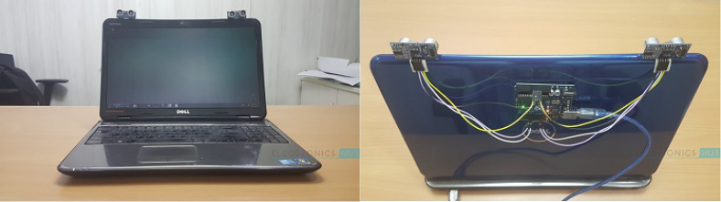

**3. IMPLEMENTATION DETAILS**

The important part of this project is to write a program for Arduino such that it converts the distances measured by both the sensors into the appropriate commands for controlling certain actions.

A similar concept is used here to measure the distance of your hand in front of both the Ultrasonic Sensors in this project. The fun part starts after calculating the distance. The hand gestures in front of the Ultrasonic sensors can be calibrated so that they can perform five different tasks on your computer. Before taking a look at the gestures, let us first see the tasks that we can accomplish.

* Play/Pause Video in VLC Player
* Rewind video
* Forward video
* Increase Volume
* Decrease Volume

The following are the 5 different hand gestures or actions that has been programmed for demonstration purpose.

* **Gesture 1**: It allows us to 'Play/Pause' VLC by placing the two hands in front of the right/left Ultrasonic Sensor at a particular far distance.
* **Gesture 2**: It allows us to 'Rewind' the video by placing a hand in front of the left sensor at a particular far distance.
* **Gesture 3**: It allows us to 'Forward' the video by placing a hand in front of the right sensor at a particular far distance.
* **Gesture 4**: It allows us to 'Increase Volume' of the video by placing a hand in front of the left sensor at a particular far distance and moving away from the Sensor.
* **Gesture 5**: It allows us to 'Decrease Volume' of the video by placing a hand in front of the left sensor at a particular far distance and get near to the sensor

**3.1 Circuit Diagram**

The circuit diagram of Arduino part of the project is shown in the following image. It consists of an Arduino UNO board and two Ultrasonic Sensors and you can power up all these components from the laptop’s USB Port.

For left sensor we connect VCC to 5V power pin in Arduino-Uno board, then we connect ground pin to first GND pin. Then we connect trigger pin to pin 2 and finally echo pin to pin 3 in Arduino board. For the right sensor, we connect VCC pin to 3.3V power pin, then we connect ground pin to second GND pin. Finally we connect trigger pin to pin 4and echo pin to pin 5 in Arduino board.

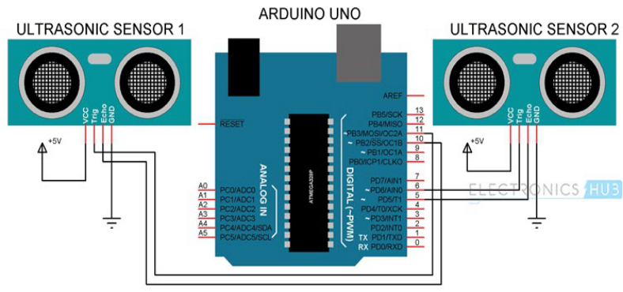

**4. SOFTWARE DESIGN**

This is the designing portion of the project which defines software solutions to one or more sets of problem. One of the main component of software design is the software requirement analysis.

**4.1 FLOW CHART**

A **flowchart** is a picture of the separate steps of a process in sequential order. It is a generic tool that can be adapted for a wide variety of purposes, and can be used to describe various processes, such as a manufacturing process, an administrative or service process, or a project plan.

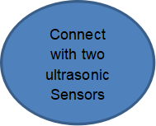

 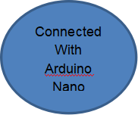







**4.2 USE CASE DIAGRAM**

A **use case** is a list of actions or event steps typically defining the interactions between a role (known in the [Unified Modeling Language](https://en.wikipedia.org/wiki/Unified_Modeling_Language" \o "Unified Modeling Language) as an [actor](https://en.wikipedia.org/wiki/Actor_(UML)" \o "Actor (UML))) and a system to achieve a goal. The actor can be a human or other external system. [Use case analysis](https://en.wikipedia.org/wiki/Use-case_analysis) is an important and valuable [requirement analysis](https://en.wikipedia.org/wiki/Requirement_analysis" \o "Requirement analysis) technique that has been widely used in modern software engineering.

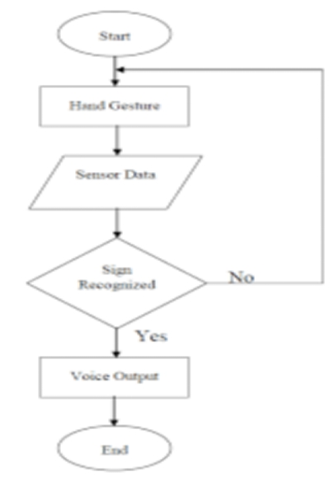

**4.3 DATA FLOW DIAGRAM**

**Data flow diagrams** are used to graphically represent the **flow** of **data** in a business information system. DFD describes the processes that are involved in a system to transfer **data** from the input to the file storage and reports generation. **Data flow diagrams** can be divided into logical and physical.

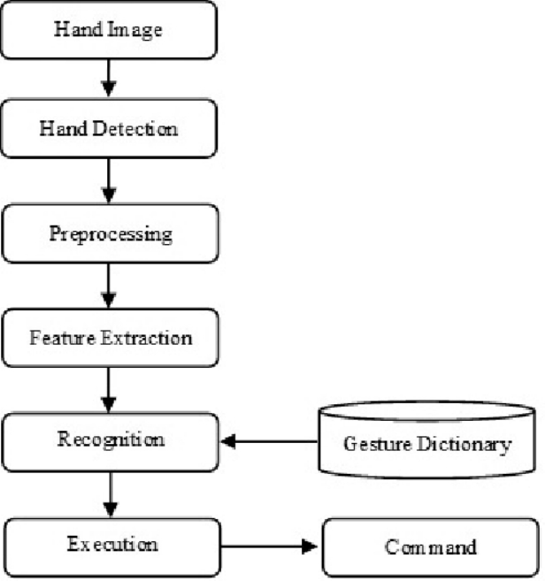

**5. CONCLUSION**

This article presents one of the solutions among various others, for operating a computer using hand gestures. It is one of the easiest ways of interaction between human and computer. It is a cost effective model which is only based on Arduino UNO and ultrasonic sensor. The python IDE allows a seamless integration with Arduino UNO in order to achieve different processing and controlling methods for creating new gesture control solutions.

**Code Snippets**

ARDUINO CODE

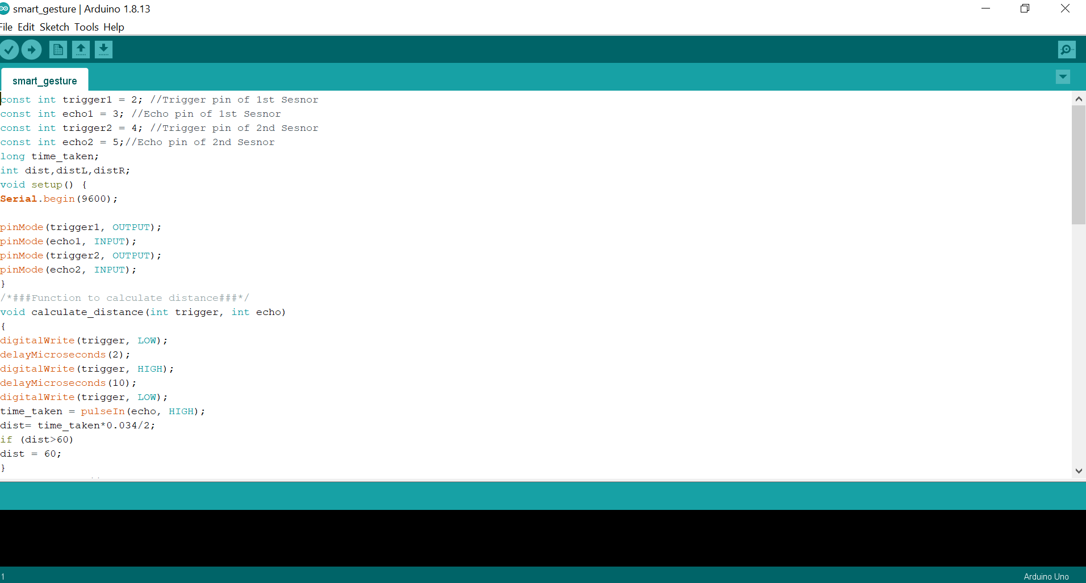

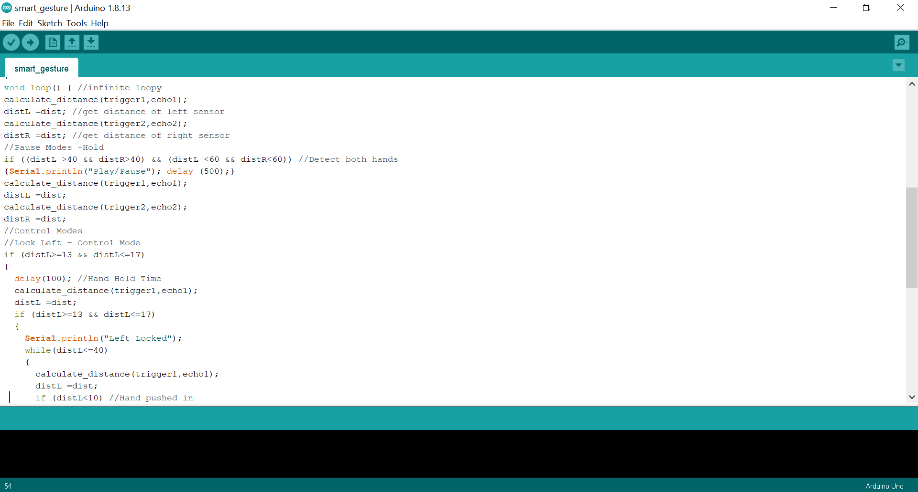

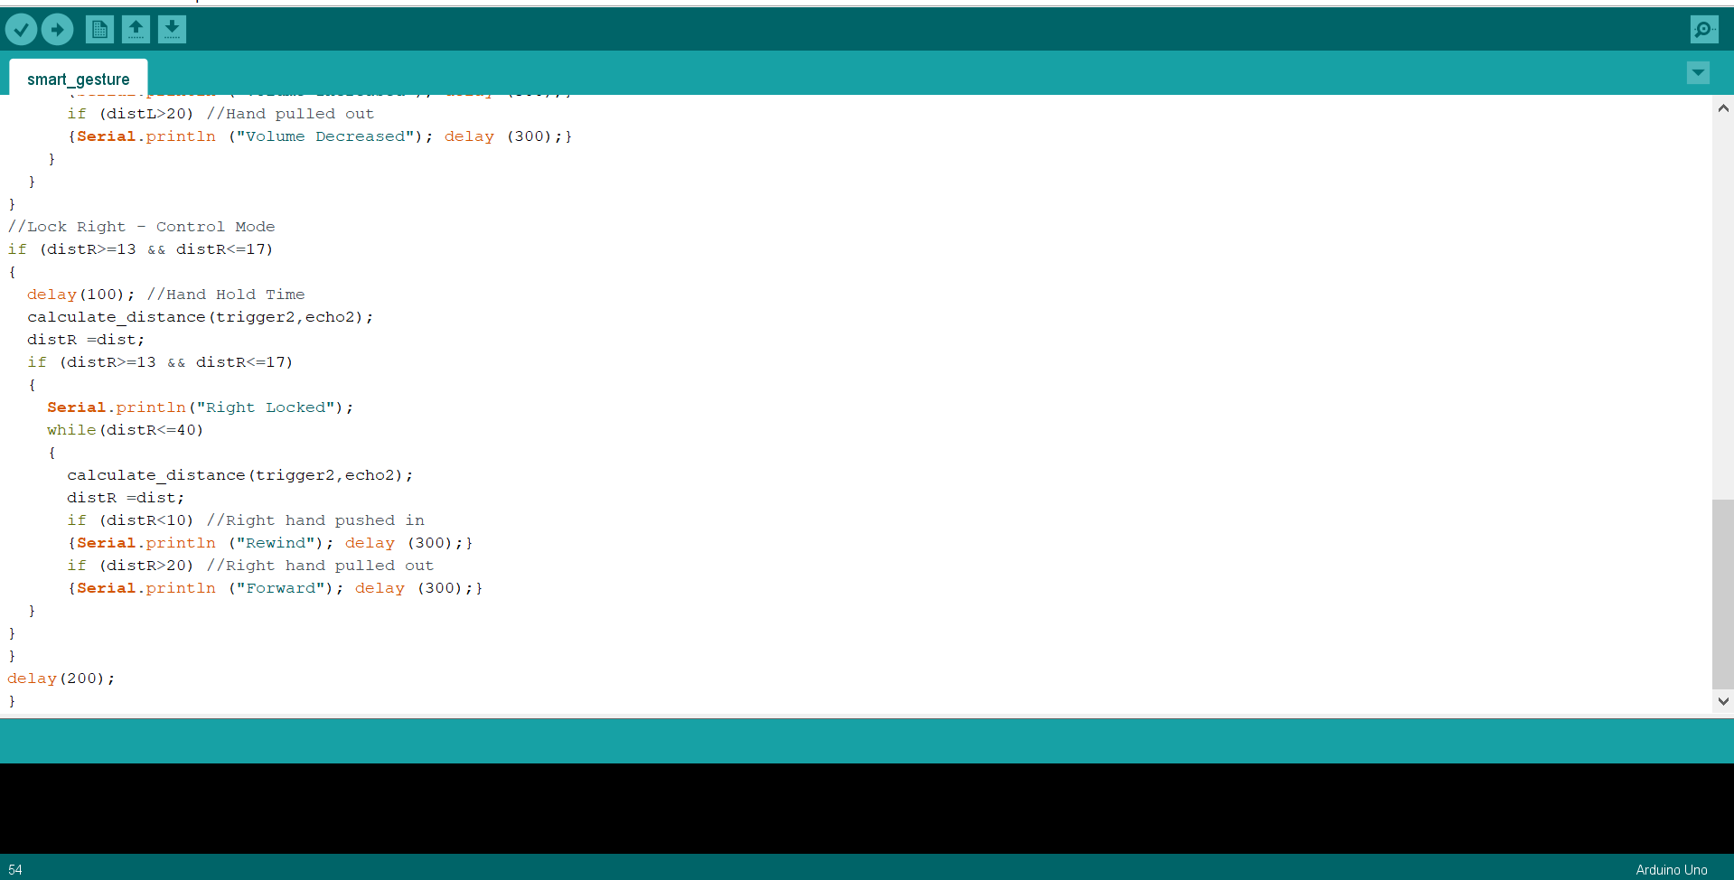

**Python Code**

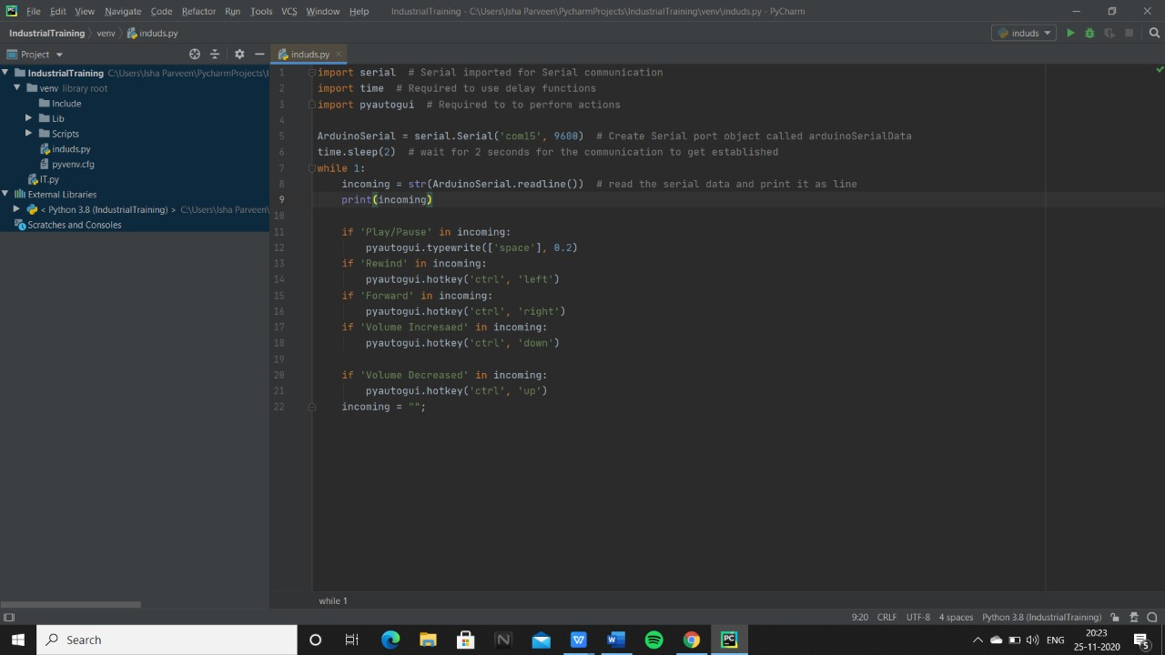

**6. FUTURE SCOPE**

Hand gesture technique is not only limited to gaming, using basic function of computer it can be useful for medical applications. This technique can also work as input method between medical instruments and human body as proposed. It can be used for operating each and every functions of computer.

**7. APPLICATION**

* In this project, we have implemented Arduino based Hand Gesture Control of Your Computer, where few hand gestures made in front of the computer will perform certain tasks in the computer without using mouse or keyboard.
* Such Gesture based Control of Computers is already present and a company called Leap Motion has been implementing such technology in computers.
* This type of hand gesture control of computers can be used for VR (Virtual Reality), AR (Augmented Reality), 3D Design, Reading Sign Language, etc.

**8. REFERENCES**

1. Software Engineering by McGraw Hill Publication

2. www.youtube.com/articles.tvac.in.faqs

3. www.udemy.com

4. https://stackoverflow.com/questions/38217414

5. Amazing-control-computer-using-hand-motion-and-arduino-d933f1